1. A graph showing up trend and up trend

   Description automatically generated
2. A graph showing up trend and price

   Description automatically generated
3. A graph with a line and a line

   Description automatically generated with medium confidence
4. dd
6. A person sitting in front of a white board

   Description automatically generated
7. A person with a beard and glasses

   Description automatically generated
8. A person with glasses and a sign

   Description automatically generatedDoji if at the bottom, then trend may be up next. Same when Doji is at the top, then next trend may be down.  
   If Doji comes in uptrend, it doesn’t mean that now down trend is going to start.   
   A person with glasses and a microphone

   Description automatically generated
10. 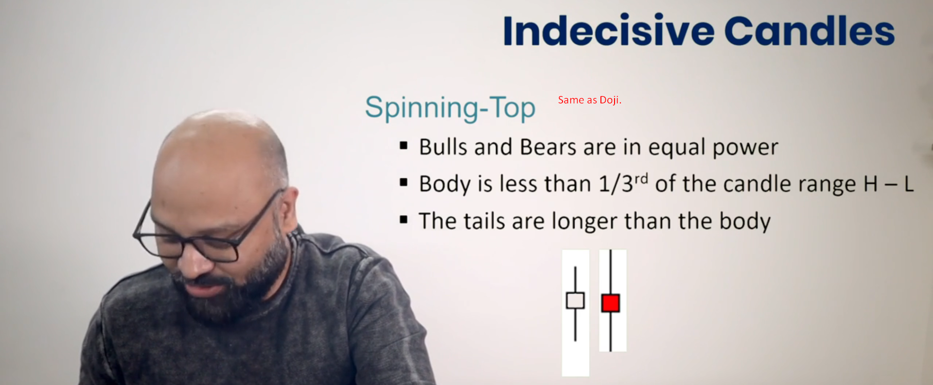
11. A graph on a white background

    Description automatically generated